

Dr. Sara, Taylor inc.
2020-02-04
Dr. Taylor
61542 Quinn Falls, Port Susanside, WI 07234
Phone: 4327609811
Fax: 2876176623

Re: Catherine, Smith
PHN: 9936513901
Birthdate: 01-Jul-2000
Address: 69855 Jennifer Gateway Apt. 319, Crystalborough, NE 30749
Patient number: 7917490956

To Whom It May Concern:

This is a medical letter to state the above patient is pregnant with expected delivery date of 13-Jul-2025. Hoping this information is satisfactory for your requirements.

Thank you.

Sincerely,
Dr. Sara, Taylor
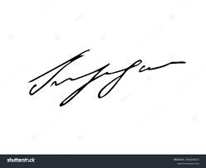
FRCS© NCMP
Clinical Assistant Professor, UBC
Department of Obstetrics and Gynecology SMH

